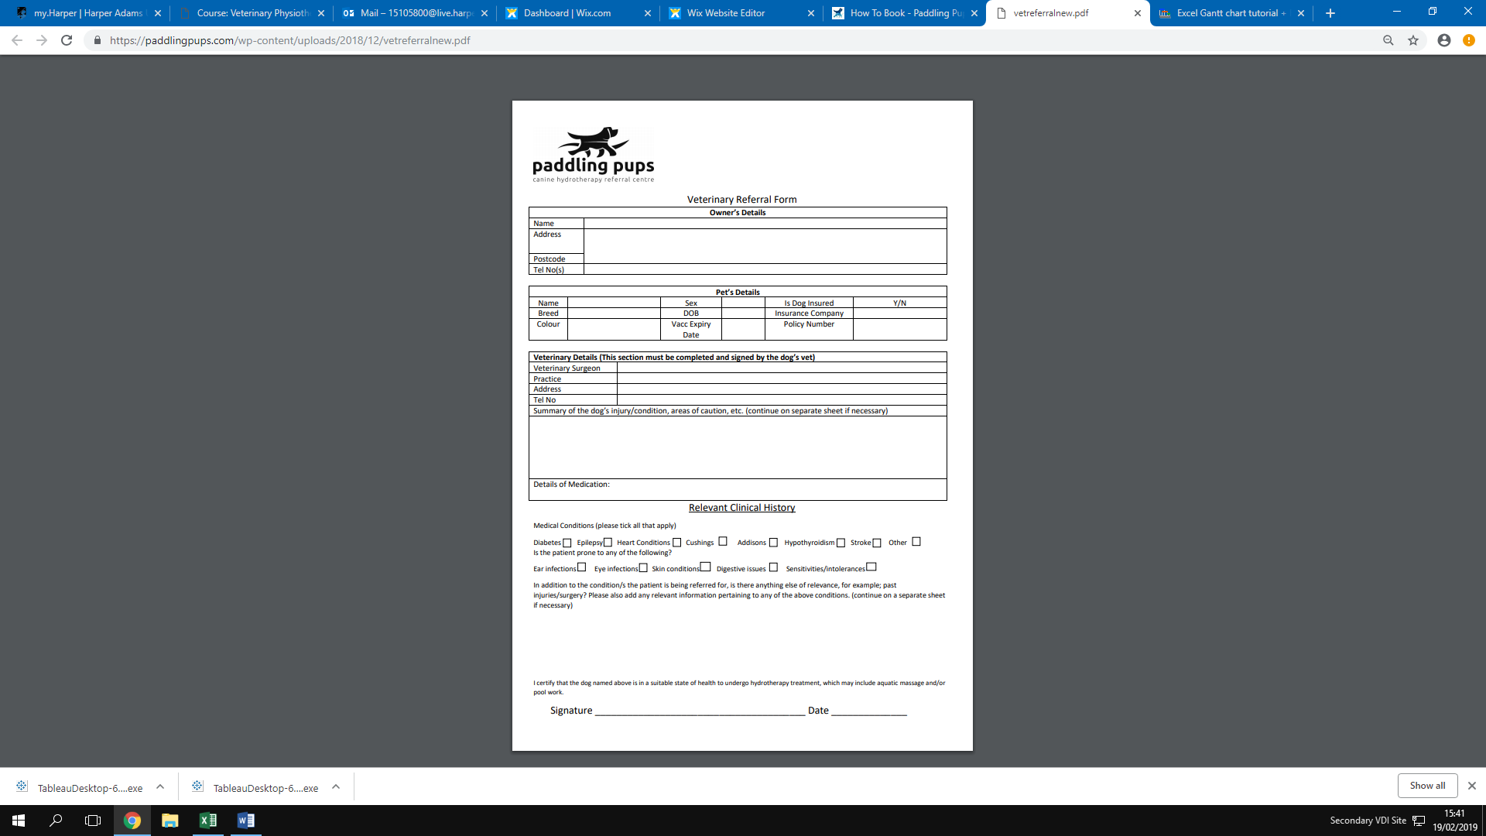

Date:

I hereby give permission for the above dog to undergo physiotherapy which may include the use of electrotherapies

Signed: